Project Report

ON

“Hospital Management/[Appointment Application System](https://www.researchgate.net/publication/312946008_Mr_Doc_A_Doctor_Appointment_Application_System?enrichId=rgreq-533cb194cce65ddfbef93d1836189256-XXX&enrichSource=Y292ZXJQYWdlOzMxMjk0NjAwODtBUzo0ODIxODEwNDM3NTcwNTZAMTQ5MTk3MjMyNzUyOA%3D%3D&el=1_x_3&_esc=publicationCoverPdf)”

SUBMITTED IN PARTIAL FULFILLMENT OF THE REQUIREMENT FOR THE AWARD OF THE DEGREE OF

#### BACHELOR OF ENGINEERING

**In**

#### Computer Science & Engineering



##### Submitted to: Er. Reema Goyal, Er. Deepika

**SUBMITTED BY:**

Vasu Rastogi (20bcs5135)

Hemang Patel (20bcs5184)

Inderjeet Singh(20bcs5138)

Madhav Upadhaya(20bcs5121)

**DEPARTMENT OF COMPUTER SCIENCE & ENGINEERING**

### CHANDIGARH UNIVERSITY GHARUAN, MOHALI

**CONTENTS**

**Topic Page No**

***Candidate’s Declaration i***

Abstract ii

Acknowledgement iii

List of Figures iv

Abbreviations

CHAPTER 1 INTRODUCTION

* 1. Introduction
  2. software and hardware required

**[Chapter-2] TRAINING WORK UNDERTAKEN**

**2.1** Basic layout of the webpage

**2.2** Styling using CSS

**2.3** Features.

**[Chapter-3] RESULTS AND DISCUSSIONS**

**[Chapter-4] CONCLUSION AND FUTURE SCOPE**

##### CHANDIGARH UNIVERSITY,GHARUAN,MOHALI CANDIDATE'S DECLARATION

We student of Bachelor of Engineering in Computer Science & Enginnering, Batch 2024, Chandigarh University, hereby declare that we have undertaken Summer Training and developed project titled “ “Hospital Management/[Appointment Application System](https://www.researchgate.net/publication/312946008_Mr_Doc_A_Doctor_Appointment_Application_System?enrichId=rgreq-533cb194cce65ddfbef93d1836189256-XXX&enrichSource=Y292ZXJQYWdlOzMxMjk0NjAwODtBUzo0ODIxODEwNDM3NTcwNTZAMTQ5MTk3MjMyNzUyOA%3D%3D&el=1_x_3&_esc=publicationCoverPdf)” during a period from June to July 2021 in partial fulfillment of requirements for the award of degree of B.E (COMPUTER SCIENCE & ENGINEERING) at CHANDIGARH UNIVERSITY GHARUAN, MOHALI. The work which is being presented in the training report submitted to Department of Computer Science & Engineering at CHANDIGARH UNIVERSITY GHARUAN, MOHALI is an authentic record of training work.

Student details and Signatures

Vasu Rastogi (20bcs5135)

Hemang Patel (20bcs5184)

Inderjeet Singh(20bcs5138)

Madhav Upadhaya(20bcs5121)

Signature of Internal Examiner Signature of External Examiner

## Abstract

Life is becoming too busy to get medical appointments in person and to maintain a proper health care. The main idea of this work is to provide ease and comfort to patients while taking appointment from doctors and it also resolves the problems that the patients has to face while making an appointment. The Website acts as a client whereas the database containing the doctor’s details, patient’s details and appointment details is maintained by a website that acts as a server.

### ACKNOWLEDGEMENT

We would like to express our deep and sincere gratitude to our Project In charge **ER Reema Goyal and ER Deepika** for giving us the opportunity to do the project and providing valuable guidance throughout this research. Their dynamism, vision and exquisite efforts have deeply inspired us. They taught us the methodology to carry out the research and to present the research work as clearly as possible. It was a great privilege for us to study and work under their guidance.

We owe the completion of my project to our project Mentor for her continuous support and guidance.

**Abbreviations**

|  |  |
| --- | --- |
| GP | general practitioner |
| MU | meaningful use |
| PRISMA | preferred reporting items for systematic reviews and meta-analyses |
| SaaS | software as a service |
| WAS | Web-based appointment system |

**CHAPTER 1**

**INTRODUCTION**

The proposed project is a smart appointment booking system that provides patients or any user an easy way of booking a doctor’s appointment online. This is a web based application that overcomes the issue of managing and booking appointments according to user’s choice or demands. The task sometimes becomes very tedious for the compounder or doctor himself in manually allotting appointments for the users as per their availability. Hence this project offers an effective solution where users can view various booking slots available and select the preferred date and time. The already booked space will be marked yellow and will not be available for anyone else for the specified time. This system also allows users to cancel their booking anytime. The system provides an additional feature of calculating monthly earnings of doctor. Doctor has to just feed the system regularly with daily earnings and the system automatically generates a report of total amount earned at the end of the month. The application uses Google forms as a front-end and sql database as the back-end.

Traditionally, medical appointments have been made with schedulers over the telephone or in person. These methods are based on verbal communications with real people and allow for maximum flexibility in complicated situations. However, because these traditional methods require the intervention of schedulers, the ability to get a timely appointment is not only limited by the availability of appointment slots, but also by the schedulers and phone lines. Patients’ satisfaction with appointment booking is influenced by their ability to book at the right time with the right health service providers.

The Internet has recently emerged as another means to make appointments. Web-based appointment scheduling has been a popular research topic. Several studies conducted satisfaction surveys and found that Web-based appointment scheduling is an extremely important feature, and most patients would use the service again.

There are two major types of Web-based medical appointment services, medical scheduling software as a service (SaaS) and proprietary Web-based scheduling systems. Medical scheduling SaaS has gained increasing prominence in recent years. These appointment systems are not built up by health care practices themselves, but are provided and maintained by health IT companies such as ZocDoc and InQuicker on a paid subscription basis. The appointment services are cloud-based and can be integrated into health care providers’ own management systems. The other type of appointment service is proprietary appointment systems, which are integrated into patient portals on providers’ websites. A patient portal is a secured Web-based service that allows patients to access their health information and communicate with their health care providers at any time. In the United States, the growth of patient portals has largely been spurred by meaningful use (MU) requirements because of the federal incentive program for adoption of electronic health records. To meet the requirements of MU and receive its incentives, the portal should be actively used by both the practice and patients.

There are two modes of Web-based appointment systems, asynchronous and real-time. In the asynchronous mode, appointments are requested through emails or electronic forms on providers’ website, and then manually processed by schedulers. In the real-time mode, patients can directly interact with providers’ scheduling management systems. Although the asynchronous Web-based appointment systems also use the Internet as a medium, they basically replicate the process of telephone-based appointment scheduling. Under the asynchronous mode, if an appointment is requested outside of a provider’s business hours, it will not be processed until schedulers return to work. Normally, Web-based appointment requests are put in the same queue as phone-call appointments, and are thus limited by the backlog of phone calls in the queue

**Advantages**

* This system helps to reduce the waiting time of the patient.
* User can select the appointment time according to his preference.
* Available and booked slots are shown in effective graphical user interface.

**Disadvantages**

* It requires an internet connection.
* It requires large database.

### 1.2 Software and Hardware tools required for Project:-

**Software:**

**HTML**

HTML stands for Hyper Text Markup Language**.** Itis the standard markup language for creating Web pages**.** It describes the structure of a Web page**.**It consists of a series of elements. HTML elements tell the browser how to display the content**.**HTML elements label pieces of content such as "this is a heading", "this is a paragraph", "this is a link", etc.

**Hypertext Markup Language** (**HTML**) is the standard markup language for documents designed to be displayed in a web browser. It can be assisted by technologies such as Cascading Style Sheets (CSS) and scripting languages such as JavaScript.

#### CSS

CSS stands for Cascading Style Sheets. CSS describes how HTML elements are to be displayed on screen, paper, or in other media. CSS saves a lot of work. It can control the layout of multiple web pages all at once. External stylesheets are stored in CSS files

#### JAVASCRIPT

**JavaScript** often abbreviated as **JS**, is a programming language that conforms to the ECMAScript specification.[7] JavaScript is high-level, often just-in-time compiled, and multi-paradigm. It has curly- bracket syntax, dynamic typing, prototype-based object-orientation, and first-class functions.

Alongside HTML and CSS, JavaScript is one of the core technologies of the World Wide Web.[8] JavaScript enables interactive web pages and is an essential part of web applications. The vast majority of websites use it for client-side page behavior,[9] and all major web browsers have a dedicated JavaScript engine to execute it.

#### MY SQL

SQL is a standard language for accessing and manipulating databases. SQL stands for Structured Query Language. SQL lets you access and manipulate databases. SQL became a standard of the American National Standards Institute (ANSI) in 1986, and of the International Organization for Standardization (ISO) in 1987

SQL can execute queries against a database, retrieve data, insert records in a database, update records

,delete records, create new databases, create new tables in a database, create stored procedures in a database, create views in a database, set permissions on tables, procedures, and views

###### Hardware:

Processor (CPU) with 2 gigahertz (GHz) frequency or above

A minimum of 2 GB of RAM

Monitor Resolution 1024 X 768 or higher

A minimum of 20 GB of available space on the hard disk .Internet Connection Broadband (high-speed) Internet connection with a speed of 4 Mbps.

### CHAPTER – 2

**TRAINING WORK UNDERTAKEN**

**2.1 Basic layout of the webpage**

This webpage is designed in a way that it will be easier for the users to get in touch with all the functionalities easily.

The basic structure of webpage goes like this:

#logo above

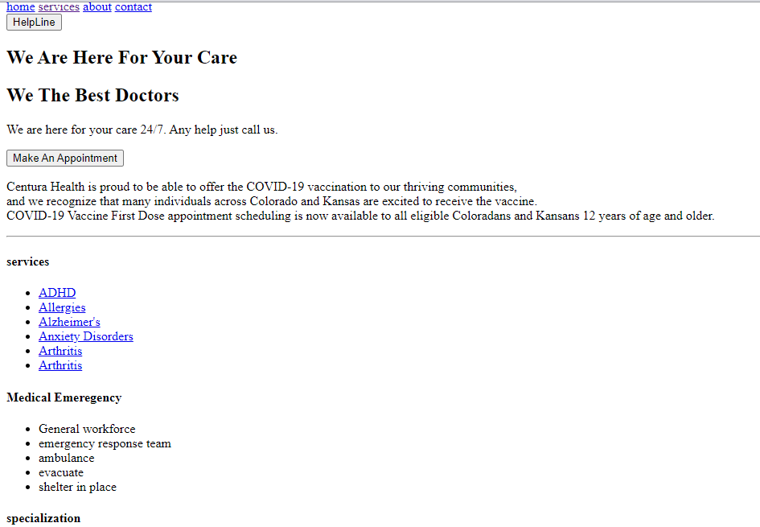

**2.2 Styling using CSS**

By using css this website got its main look and feel.

Adding features like

*Big eye-catching blueish colour to the important items in website,

*Background picture to enhance UX of the website,

*Added a footer and a header

*Header includes features like home, services, about & contact

*Footer have services, Medical Emergency, specialization and project by.

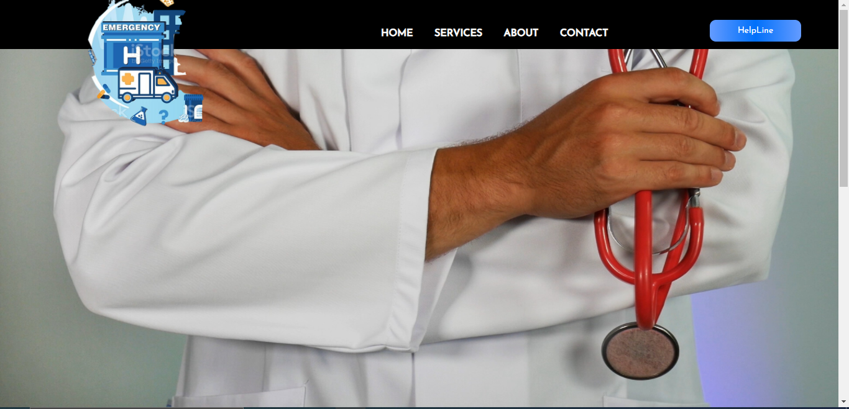

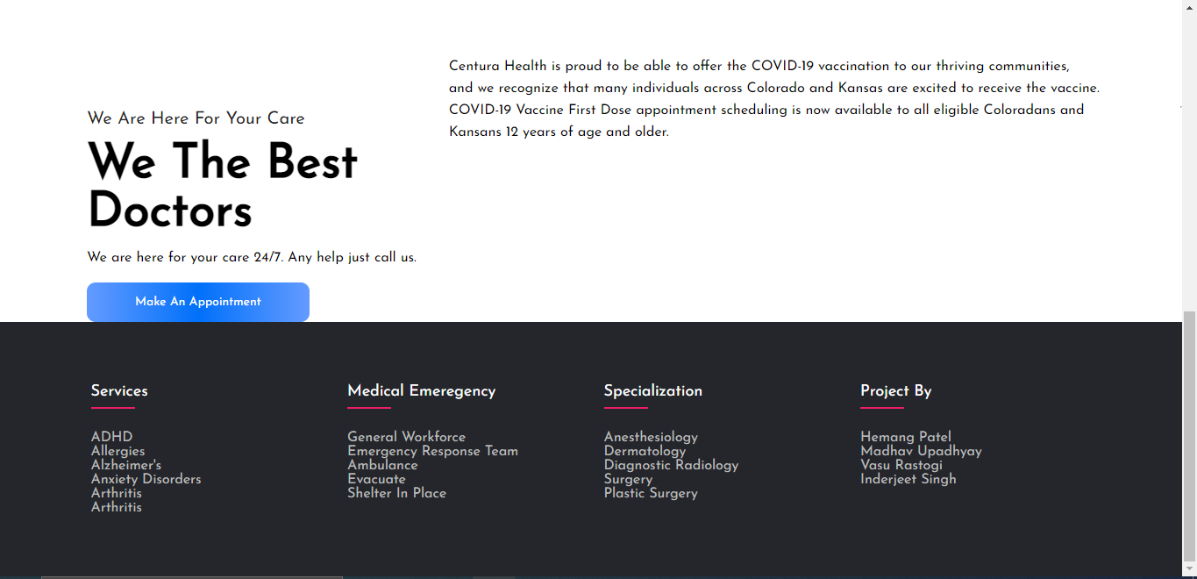

**2.3 Features**

*On services panel in Footer section, We added links to all diseases that this hospital takes cares of.

*On Project­_by Pannel in Footer section we added LinkedIN Profiles of the Team.

*At header sections we added a helpline button that tends to redirect to call to hospital’s number.

*On clicking Make an appointment, the page will be redirected to a google form that takes info of the patient and sends it to the database

*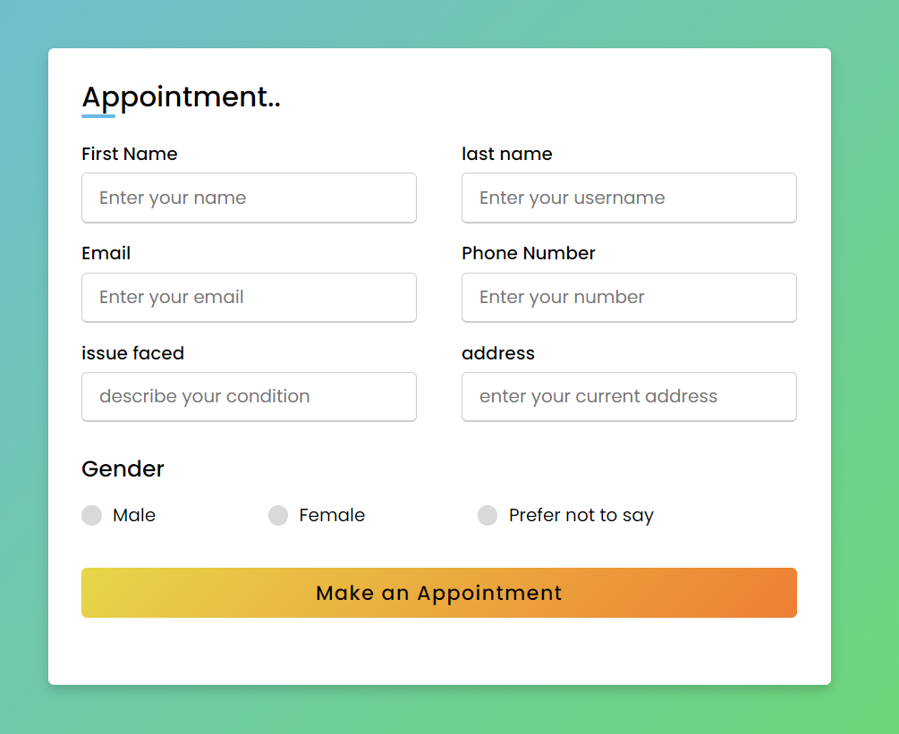

#### CHAPTER 3

**RESULTS AND DISCUSSIONS**

##**CODE**##

#HTML#

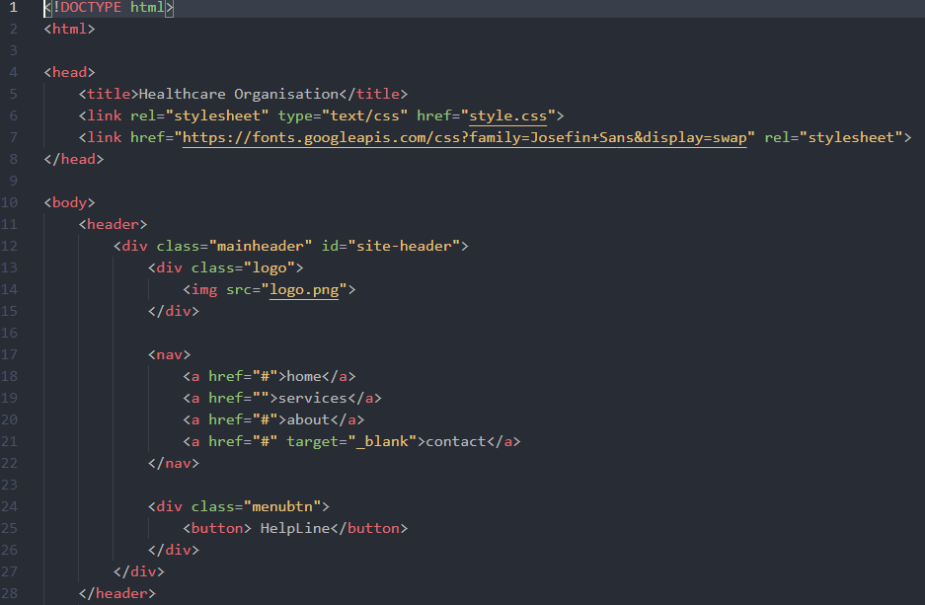

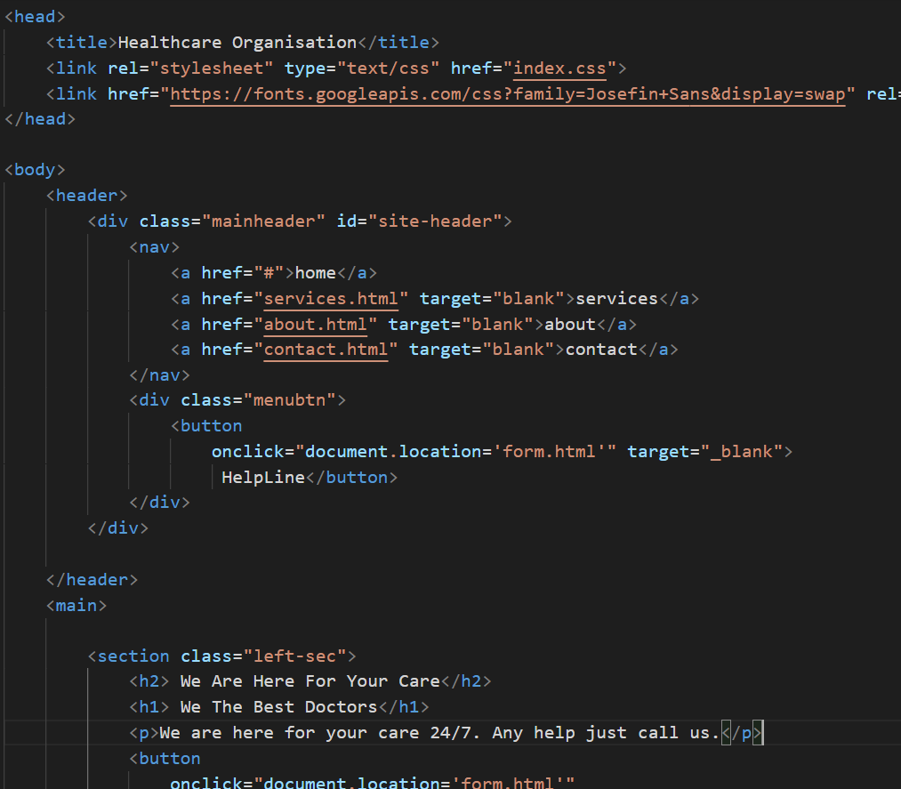

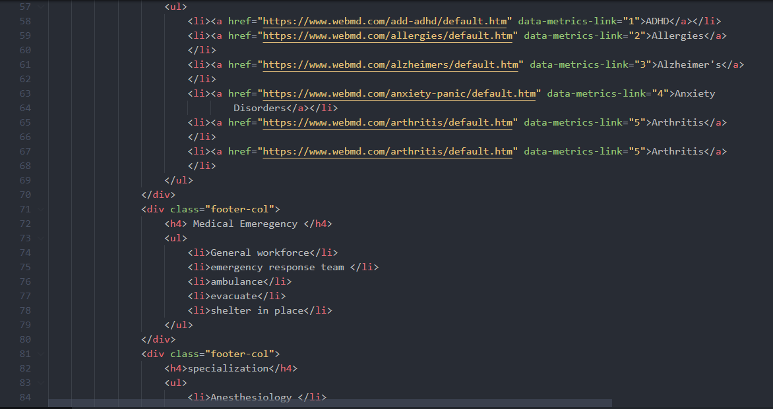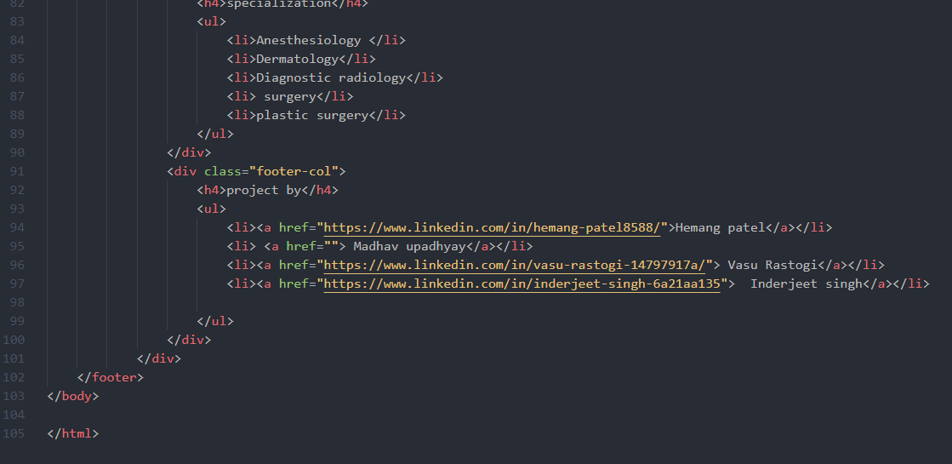

**#CSS#**

* {

  margin: 0;

  padding: 0;

  box-sizing: border-box;

  font-family: "Josefin Sans", sans-serif;

}

header {

  width: 100%;

  height: 100vh;

  background-image: url("health4.jpg");

  background-repeat: no-repeat;

  background-size: 100% 100%;

}

.mainheader {

  width: 100%;

  height: 80px;

  display: flex;

  justify-content: space-between;

  align-items: center;

  background-color: black;

}

.mainheader .logo img {

  width: 500px;

  height: 400px;

  padding-top: 20%;

}

.mainheader nav {

  width: 450px;

  display: flex;

  justify-content: space-around;

  align-items: center;

  font-weight: bold;

  padding-right: 50px;

}

.mainheader nav a {

  text-decoration: none;

  color: white;

  text-transform: uppercase;

  padding-top: 50px;

  text-align: center;

  padding-bottom: 20px;

}

.menubtn {

  margin-right: 60px;

  padding-top: 20px;

}

.mainheader button {

  padding: 10px 45px;

  text-align: center;

  font-size: 14px;

  color: #fff;

  border: none;

  background-image: linear-gradient(to right, #649bff, #0070fa, #649bff);

  border-radius: 10px;

}

main {

  width: 100%;

  display: flex;

  justify-content: space-between;

  align-items: center;

}

main .right-sec {

  padding-right: 60px;

  font-size: larger;

  padding-right: 50px;

  font-style: normal;

  font-family: "Trebuchet MS", "Lucida Sans Unicode", "Lucida Grande",

    "Lucida Sans", Arial, sans-serif;

  font-size: inherit;

  line-height: 1.6;

  margin-bottom: 1rem;

  text-rendering: optimizeLegibility;

}

main .right-sec.p {

  font-size: inherit;

  line-height: 1.6;

  margin-bottom: 1rem;

  text-align: right;

}

main .left-sec {

  padding-left: 100px;

  padding-top: 150px;

}

.left-sec h2 {

  font-size: 20px;

  text-transform: capitalize;

  font-weight: lighter;

  color: #242424;

  margin-top: 100px;

}

.left-sec h1 {

  font-size: 55px;

  text-transform: capitalize;

  font-weight: 700;

  margin: 15px 0;

}

.left-sec p {

  margin-bottom: 20px;

}

.left-sec button {

  padding: 15px 55px;

  text-align: center;

  font-size: 14px;

  color: #fff;

  border: none;

  background-image: linear-gradient(to right, #649bff, #0070fa, #649bff);

  border-radius: 10px;

  transition-duration: 0.4s;

  cursor: pointer;

}

* {

  margin: 0;

  padding: 0;

  box-sizing: border-box;

}

.container {

  max-width: 1170px;

  margin: auto;

}

.row {

  display: flex;

  flex-wrap: wrap;

}

ul {

  list-style: none;

}

.footer {

  background-color: #24262b;

  padding: 70px 0;

}

.footer-col {

  width: 25%;

  padding: 0 15px;

}

.footer-col h4 {

  font-size: 18px;

  color: #ffffff;

  text-transform: capitalize;

  margin-bottom: 35px;

  font-weight: 500;

  position: relative;

}

.footer-col h4::before {

  content: "";

  position: absolute;

  left: 0;

  bottom: -10px;

  background-color: #e91e63;

  height: 2px;

  box-sizing: border-box;

  width: 50px;

}

.footer-col ul li a {

  font-size: 16px;

  text-transform: capitalize;

  color: #ffffff;

  text-decoration: none;

  font-weight: 300;

  color: #bbbbbb;

  display: block;

  transition: all 0.3s ease;

}

.footer-col ul li {

  font-size: 16px;

  text-transform: capitalize;

  color: #ffffff;

  text-decoration: none;

  font-weight: 300;

  color: #bbbbbb;

  display: block;

  transition: all 0.3s ease;

}

/*new learnt */

.footer-col ul li a:hover {

  color: #ffffff;

  padding-left: 8px;

}

/*responsive learnt*/

@media (max-width: 767px) {

  .footer-col {

    width: 50%;

    margin-bottom: 30px;

  }

}

@media (max-width: 574px) {

  .footer-col {

    width: 100%;

  }

}

And The Result is:







**Discussion**

**Principal Findings**

The Web-based medical appointment reframes the way to communicate with providers’ appointment management systems. Compared with traditional appointment methods, Web-based appointment scheduling has unique advantages and disadvantages. In this section, the key benefits and barriers to the adoption of Web-based appointment scheduling will be discussed.

**Patient-Centeredness**

Patient-centeredness is one of the six quality aims proposed by the Institute of Medicine to improve health care quality in INDIA. Web-based medical scheduling as a medical self-service offers a more patient-centered means to make appointments. Most Web-based appointment systems are interfaced with a calendar-like list. Patients can browse and select the most convenient appointment time from the available time slots. In contrast, patients are only given very limited options of available time slots in traditional appointment systems. Besides time slots, some of the Web-based systems allow patients to filter physicians by physicians’ attributes such as education background, experience, gender, and reviews from other patients.

Another convenience from improved patient access is that patients can fill out registration forms, get prescreened and review practice policies online, before they show up and this can smooth workflow and reduce misunderstandings.

In the self-servicing Web-based appointments, patients’ own descriptions of the reason for visit are often more detailed and illuminating. Sometimes, patients might be uncomfortable or unable to vocalize certain symptoms (eg, sexual health problems) to the scheduler over the phone or in person, and they may make an untrue statement. They tend to be more candid when they schedule online by themselves.

**Reduced No-Show Rates**

No-show is a significant cause of wasted clinical resources. The patient-centered design in Web-based appointments has the potential to decrease no-show rates. The reasons for the reduction of no-shows after implementing Web-based scheduling have not been systematically studied in the literature, but it could be attributed to the improved access in Web-based scheduling that allows patients to easily verify, cancel, and reschedule their appointments. A possible reason is that patients feel more responsible for their appointments when they make appointments by themselves.

**Reduced Waiting Time**

Waiting is an indicator of service quality and a source of dissatisfaction that affects health care outcomes and patient retention. Long waiting time may make patients seek care from other providers and thus this can potentially cause a loss in revenue.

The most cited benefit of real-time scheduling is after-hour access. Real-time scheduling requires minimal intervention of schedulers and thus can help reduce the waiting time caused by human factors. The available time slots are transparent to patients through the Web interface. Patients are free to claim available appointment slots anytime and anywhere.

The support of same-day or soon appointments by some real-time systems can help further shorten the time between when the appointment is requested and when the medical service is fulfilled. Although there is a concern that the ability to book in advance for chronic conditions might be diminished by same-day appointments due to the limited number of appointment slots, same-day appointments could produce positive outcomes as long as the provider can find a balance in his or her capacity. For providers, it is possible to reuse the time slots released due to late cancellations. These allotted time slots will be otherwise wasted if traditional appointment methods are used because of the longer turnaround time.

**Barriers to Adoption**

It is well known that medicine has lagged in the adoption of new technologies. Although Web-based appointment scheduling comes with many benefits, some providers and patients are reluctant to use it. By 2007, only about 3.2% of the population in 7 European countries (Denmark, Germany, Greece, Latvia, Norway, Poland, and Portugal) had used the Internet to make medical appointments. Only about 15% of public hospitals and 18% of private hospitals in Italy allowed appointments to be made online in 2008-2009. According to a study conducted by Google and Compete (a research vendor) in 2012, only 21% of patients booked appointments via computer or mobile devices. Only about 7% of primry care practices in Canada and 30% in the United States offered Web-based appointment services in 2012. As of 2014, 67% of general practitioner (GP) practices in Scotland have websites and only 10% of them support Web-based appointments.

There are many reasons for the slow adoption. First, the transition requires the practices to give up legacy systems they have relied on and change the fundamental workflow and administration already established. A large investment would be required for the providers to move toward new centralized Web-based scheduling systems.

Second, real-time Web-based scheduling lacks flexibility in the medical setting because the automatic appointment systems are not intelligent enough to handle cases not predefined. Unlike the appointment scheduling in other industries such as airline ticket booking, which has strict rules, medical appointments are tailored based on the knowledge of physicians and patients, and thus can be rather flexible. Physicians have their own preferences in appointment patterns, whereas the booking preferences for different patients can be rather distinct and can change over time. The “Mabel factor” depicts a situation in which a scheduler knows how to balance the practice’s available resources and human factors such as physicians’ preferences and patients’ needs. It is challenging for real-time Web-based scheduling systems to achieve the same level of flexibility. In reality, physicians have to give up their preferred scheduling patterns to accommodate the simplified real-time scheduling rules.

Third, safety is a concern. It is challenging to triage patients who made appointments through real-time Web-based appointment systems. Patients may misuse Web-based appointment systems for urgent conditions that need to be handled immediately by an emergency room or urgent care. Because schedulers are no longer involved in the appointment process, the systems should be capable of triaging patients and stratifying their risks accurately. Some practices just display static warning messages on their Web presence to stop patients from using their appointment systems for urgent conditions. Some real-time systems still rely on human reviewers to screen for possible emergencies. Very few real-time appointment systems reported in the literature can automatically identify emergency conditions.

. Automatically generated email- or message-based reminders can also help reduce no-shows. Some practices refuse to expose physicians’ open time slots, because they believe that patients might think the physicians do not work hard enough when they see many openings.

In addition to the four main barriers, studies found that the following common problems from the patient side considerably affect the adoption of Web-based scheduling: unawareness of the Web-based appointment service, low penetration and distrust of the Internet, low computer skills, and the preference for verbal communications.

**Chapter-4**

**Conclusion and Future scope**

In this Project, we made a website and also sought evidence from the literature to discuss the benefits and challenges of implementing Web-based medical appointment systems. Compared with traditional appointment methods, Web-based appointment scheduling is more patient-centered and has many advantages due to improved access. After implementing Web-based appointment systems, many practices have shown positive changes such as reduced no-show rate, decreased staff labor, decreased waiting time, and improved patient satisfaction.

Although these changes suggest Web-based appointment systems could produce positive outcomes, this assertion should be further reinforced by more sophisticated study designs. As in some studies, the Web-based appointment services are components of portals and it is hard to measure their impacts statistically. Some studies reported results without controlling for other factors. It is possible that the positive outcomes are produced by the other factors or by the combination of the Web-based appointment systems and the other factors.

Providers and patients both have reasons for the slow adoption of Web-based appointment scheduling. Cost, flexibility, safety, and integrity are major reasons discouraging providers from using Web-based scheduling. Patients’ reluctance to adopt Web-based appointment scheduling is mainly influenced by their past experiences using computers and the Internet, as well as their communication preferences.

Overall, the literature suggests a growing trend for the adoption of Web-based appointment systems. The findings of this review suggest that there are benefits to a variety of patient outcomes from Web-based scheduling interventions with the need for further studies.

# REFERENCES

1. W3Schools
2. Freecodecamp.org
3. Javascript.info
4. Csstricks.com
5. Codeacademy.com
6. Pexels.com
7. Pixabay.com